

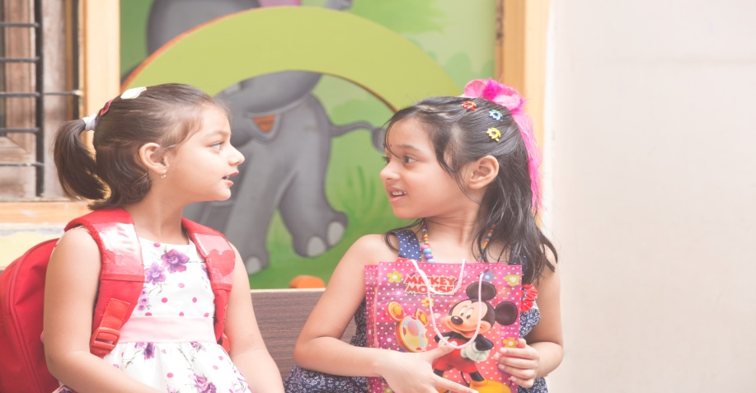
School Campus
S-227, Shivalik Nagar,
Behind ICICI Bank, Haridwar.

World’s Best School, Now in INDIA
www.sheffieldschoolindia.com
Ph. 8941001121, 01334-231151

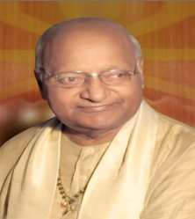
About Krishnas Welfare Society
Founded on the values and dreams of Late. Shri. Krishna Kumar Sharma Ji [(our beloved father) renowned, prominent social worker, leader and writer)] and releasing the need for a good school in the society and by putting up their experience & knowledge together, Krishnas Welfare Society started up with a unique concept that aims to provide every child with an excellent educational experience. After establishing and successfully running various schools in Uttrakhand for the last 8 years, Krishnas Welfare Society is now ready with “Sheffield Krishnas International” School.

Congrats! Winner and Nominee of The Best Upcoming School Chain In INDIA 2017-18
Photos of Awards and Certificates

“Everyday we have the privilege of witnessing wonderful children achieve and fulfil their own unique potential and emerge more confident as individuals”.
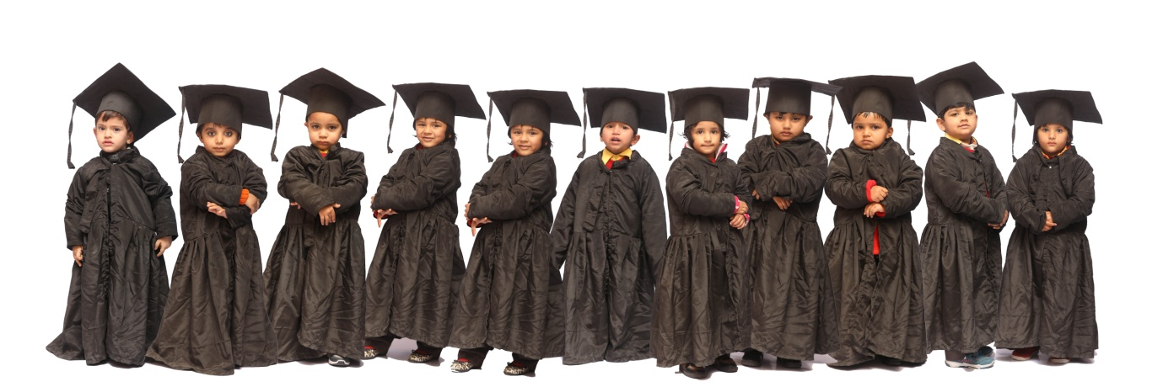
Our mission:- Our value base school nurtures curiosity and creativity through an inspiring, broad and enjoying curriculum where learning is at the heart of all that we do. Our mission is to create a happy, secure and stimulating learning environment in which all members of the school community can grow in confidence and develop their full potential.
We believe that: HAPPY CHILDREN LEARN
Our Vision :- We aim to manage an outstanding, value based school at the heart of our culturally diverse community, enabling our children to achieve their highest potential in all areas of the curriculum.

Photo and quotation of Page No. 3 in continuation

FACILITIES
At SHEFFIELD School, our endeavour is to provide world class education to our students by guiding them under the CBSE/ IB / Montessori & Various International patterns. Apart from the unique innovative and creative School System, our aim is to provide an excellent environment where students develop their personality and grow to the optimal potential holistically.
The school offers a perfect blend of world-class education with unique curriculum and sports with life skills, thus preparing the Students for a better tomorrow.
Collage of photographs if space is there.

What makes us unique – not only different but special!
 The educational programme at Sheffield addresses the total personality development of the child. Academics is not the only form of education that we practice. We believe in a holistic approach.
Trained , supportive and motivated teachers.
Parents workshops and orientation.

Our classrooms are exclusively customized. We have well designed computer lab, science lab, library and art and craft room.

All possible safety measures like:-
CCTV,Fire extinguisher, First aid kit and training , Good and Bad touch sessions.
Photos

After establishing and successfully running various schools in Uttrakhand for the last 8 years, Krishnas Welfare Society in now ready with two new ventures.
- Saplings
(The Future Prudence School)
Coming soon at Roshnabad

- Krishnas International Activity Club:-
Where mothers as well as kids can have some more quality time with each other in addition to be healthy ………………….

Launching Special Classes (4 p.m to 6:p.m) Monday to Friday
- All Dance forms
- Health and wellness programme
(Like Zumba, Yoga & Arobics)
- Art & Craft
- Computer
Transport Available
For more details contact
S-227, Shivalik Nagar, BHEL,
Haridwar
Ph. No. 8941001121, 01334-231151

